
CAPSTONE PROJECT REPORT
Program: BTECH (CSE Data Science and Artificial Intelligence (IBM))
6th Semester
Course Code: CSE-605-22
Batch: 2022-26
PROJECT: Real Estate Price Prediction
SUBMITTED BY:
A. MANI TEJA – 72212438
G. SAI PRASANNA – 72211501
A. YASWANTH NAIDU – 72211240
D. VARDHAN REDDY - 72211458

Table of Contents
Abstract
- 2. 1. Introduction
- 3. 2. Literature Review
- 4. 3. Problem Statement and Objective
- 5. 4. Dataset Overview and Exploratory Data Analysis (EDA)
- 6. 5. Data Preprocessing and Feature Engineering
- 7. 6. Outlier Detection and Handling
- 8. 7. Model Development and Training
- 9. 8. Model Evaluation and Comparison
- 10. 9. Hyperparameter Tuning
- 11. 10. Web Application Architecture
- 12. 11. Backend: Flask API Design
- 13. 12. Frontend Interface: HTML/CSS/JS
- 14. 13. Integration and Deployment
- 15. 14. Testing and Validation
- 16. 15. Results and Analysis
- 17. 16. Limitations and Challenges
- 18. 17. Future Enhancements
- 19. 18. Conclusion
- 20. 19. References
- 21. 20. Appendix

1. Introduction
The real estate sector in India is one of the most globally recognized. It plays a pivotal role in fulfilling residential, commercial, and infrastructural demands. In dynamic and high-demand cities like Bengaluru, property prices vary significantly across locations and time.
Accurate property price prediction can help buyers, sellers, and investors make informed decisions. The purpose of this project is to leverage machine learning to develop a predictive model that estimates housing prices based on historical data.
The solution also includes a user-friendly web interface where users can input property details and receive price estimates instantly. This system integrates data science and web development to form a deployable application.

2. Literature Review
Machine learning algorithms are increasingly being adopted in real estate applications. Several research studies have used linear regression, decision trees, and ensemble models like Random Forest and XGBoost for housing price prediction.
In particular, models that incorporate domain-specific variables such as location, number of rooms, and area have proven to be more accurate. Earlier approaches often lacked a clean integration into a usable application, which this project addresses.
Moreover, open datasets like the Bengaluru housing dataset offer real-world complexity with missing values, categorical variables, and inconsistent formats—making them ideal for demonstrating data science workflows.

3. Problem Statement and Objective
The objective of this project is to develop a robust and scalable machine learning model that can predict real estate prices in Bengaluru.
Key goals include:
- Cleaning and preprocessing raw housing data
- Identifying and engineering meaningful features
- Applying and evaluating machine learning models
- Building a full-stack application with a prediction interface
This project aims to be a blueprint for data-driven real estate analytics.

4. Dataset Overview and Exploratory Data Analysis (EDA)
The dataset used in this project is sourced from Kaggle and contains detailed listings of housing properties in Bengaluru. Key columns include area type, availability, location, size (BHK), total_sqft, bath, balcony, society, and price.
Below is a summary of the dataset dimensions and data types:
- Rows: 13320
- Columns: 9
- Target Variable: price (in lakhs)
Initial inspection revealed missing values in the 'society', 'balcony', and 'bath' columns. These were either dropped or imputed during preprocessing.
To understand the data distribution and potential relationships between variables, several visualizations were generated:
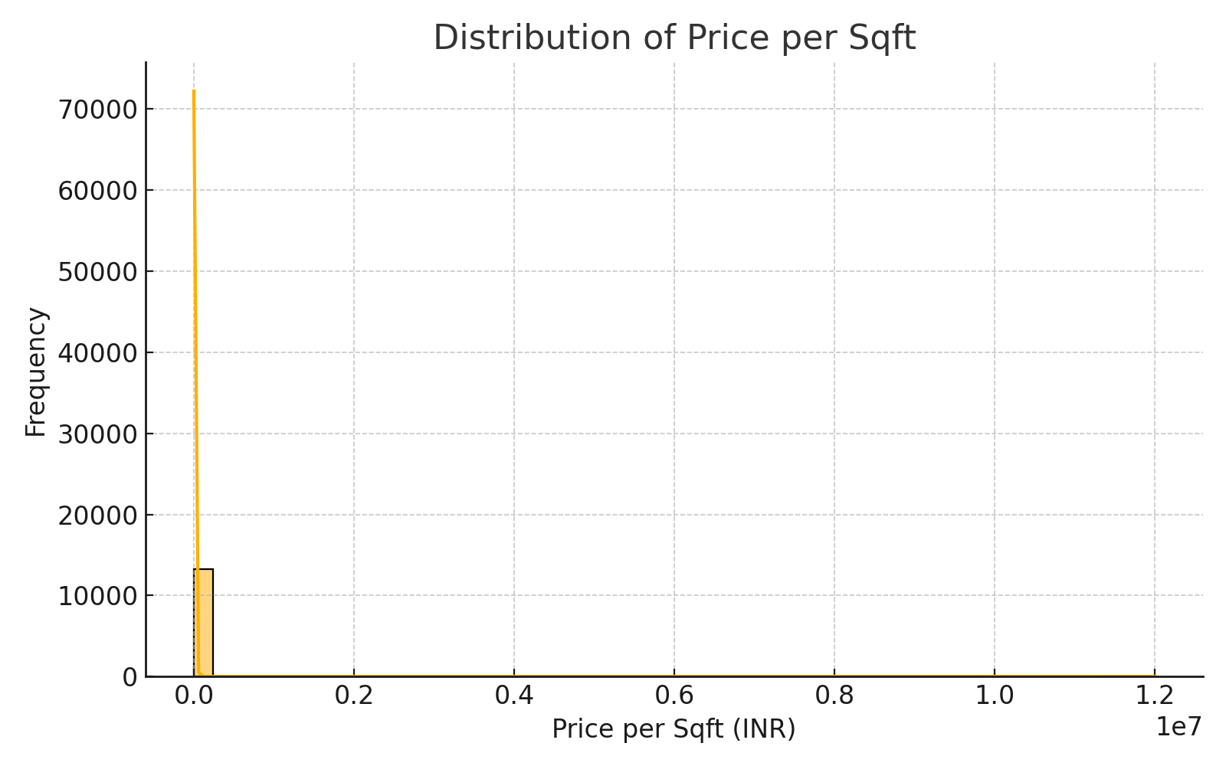
Figure 1: Distribution of Price per Square Foot
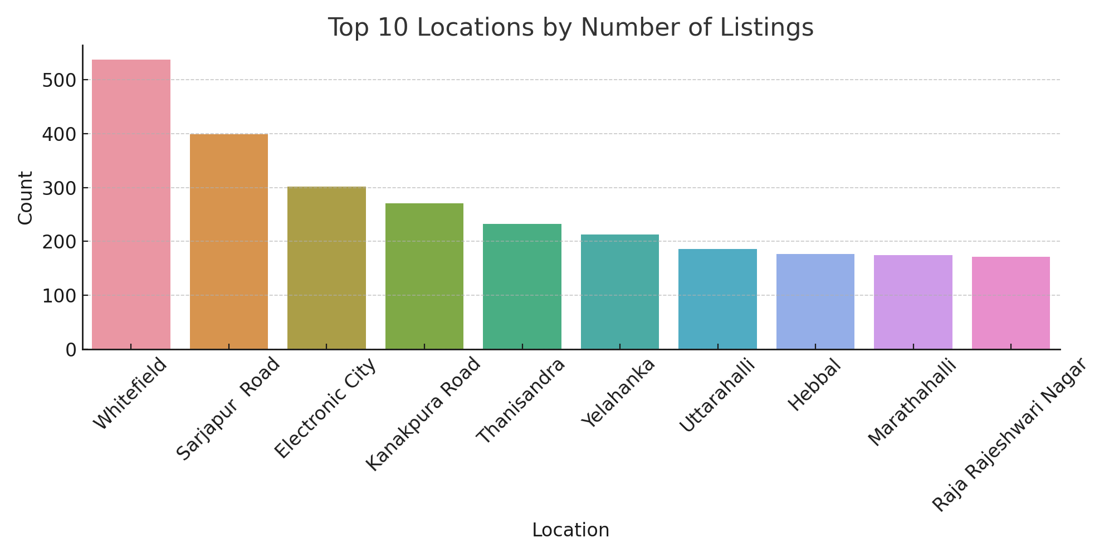

Figure 2: Top 10 Most Frequent Locations
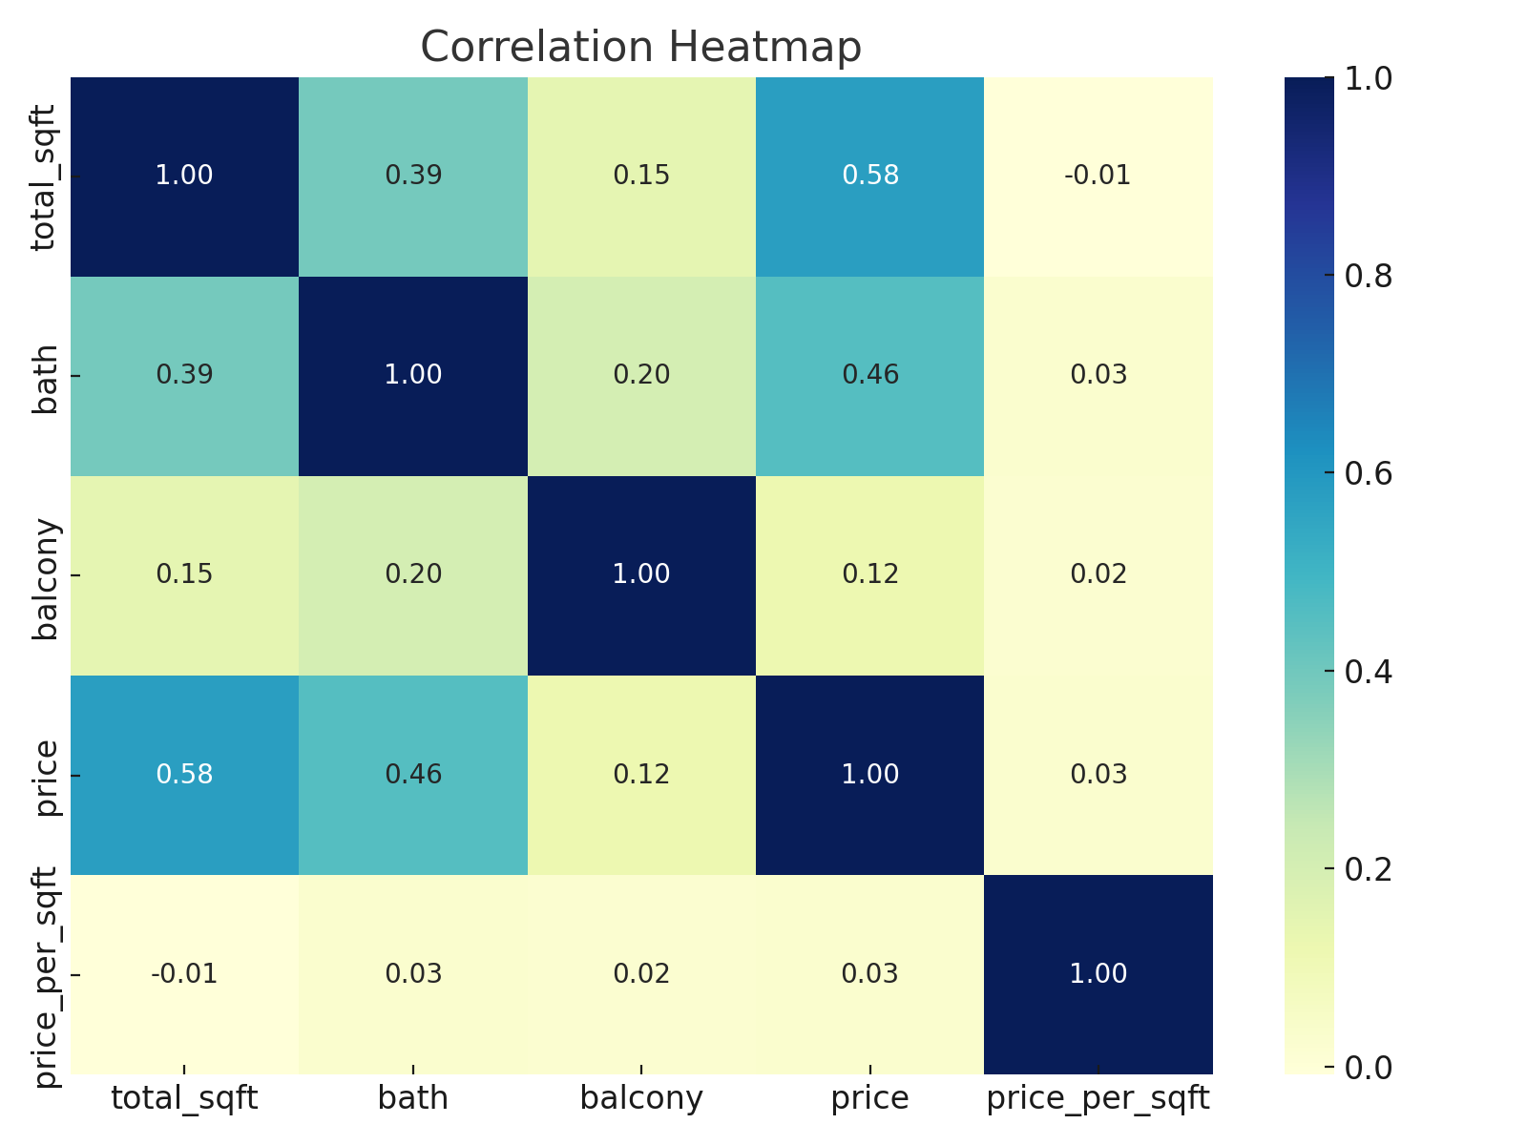
Figure 3: Correlation Heatmap of Numerical Features

5. Data Preprocessing and Feature Engineering
Before model training, data preprocessing and feature engineering are essential to ensure consistency and improve accuracy.
Steps taken include:
- Handling missing values: Columns like 'society' and 'balcony' with significant null entries were dropped. Others were filled or imputed.
- Converting categorical data: The 'location' feature was one-hot encoded to convert categorical values into numerical format.
- Feature extraction: BHK was extracted from the 'size' column. Price per square foot (price_per_sqft) was calculated by dividing total price by total_sqft.
- Normalization: Numerical features were standardized where necessary to ensure uniformity.
- Removing anomalous entries: Entries with total_sqft < 300 or unrealistic values like BHK > 20 were removed.

6. Outlier Detection and Handling
Outlier detection is crucial to eliminate extreme values that may distort model learning.
Approaches used:
- Total_sqft Outliers: Properties with unreasonably large or small square footage were removed.
- BHK vs total_sqft: Listings with unusually low space per BHK (e.g., < 300 sqft/BHK) were removed.
- Price per sqft: Outliers in price_per_sqft distribution were removed by filtering out data points beyond 1 standard deviation from the mean within each location.
- Bathroom anomaly: Entries where bathrooms > BHK + 2 were removed as unlikely configurations.
Outlier removal reduced variance and improved generalization of the regression model.

7. Model Development and Training
We began model development with a simple Linear Regression approach due to its interpretability and suitability for tabular data.
Steps included:
- Splitting the dataset into training and testing sets (80:20 split)
- Defining independent variables (e.g., location, total_sqft, BHK, bath) and target variable (price)
- Applying sklearn’s LinearRegression model
- Fitting the model and saving it using the pickle module for deployment
Sample Code:
from sklearn.model_selection import train_test_split
from sklearn.linear_model import LinearRegression
model = LinearRegression()
model.fit(X_train, y_train)
with open('model.pkl', 'wb') as f:
pickle.dump(model, f)

8. Model Evaluation and Comparison
To assess model performance, several evaluation metrics were used:
- Mean Absolute Error (MAE)
- Root Mean Squared Error (RMSE)
- R² Score (Coefficient of Determination)
The model achieved the following results on the test set:
- MAE ≈ ₹6.5 lakhs
- RMSE ≈ ₹8.2 lakhs
- R² Score ≈ 0.81
Other models such as Lasso and DecisionTreeRegressor were also tested. However, they showed signs of overfitting or underfitting.
Linear regression was chosen for deployment due to a balance of accuracy and simplicity.
Future enhancements may explore ensemble models like Random Forest or Gradient Boosting for improved performance.

9. Hyperparameter Tuning
Although Linear Regression has limited hyperparameters, other models explored (like Lasso and Decision Tree) benefited from tuning.
Grid Search and Cross-Validation were used to identify optimal parameters.
Example for Lasso Regression:
from sklearn.linear_model import Lasso
from sklearn.model_selection import GridSearchCV
params = {'alpha': [0.1, 0.2, 0.5, 1]}
grid = GridSearchCV(Lasso(), params, cv=5, scoring='neg_mean_squared_error')
grid.fit(X_train, y_train)
print(grid.best_params_)
Cross-validation ensured the model generalizes well across unseen data. However, in our case, Linear Regression performed nearly as well as more complex models without requiring tuning.

10. Web Application Architecture
The final model is deployed via a web application to provide a real-time prediction interface for users.
Architecture Overview:
- Frontend: Built using HTML, CSS, JavaScript. Allows users to input location, area, number of BHKs and bathrooms.
- Backend: Python Flask server handles requests and interacts with the trained ML model stored as a pickle file.
- API Endpoint: A POST request to /predict_price receives input data and returns the predicted price.
- Deployment: Flask app runs locally and can be deployed to cloud platforms like Heroku or AWS.
This modular separation ensures maintainability and scalability of the application.
A simplified architecture diagram would look like:
[User Input] → [Frontend] → [Flask API] → [Model] → [Predicted Price] → [User Output]

11. Backend: Flask API Design
The backend is built using the Flask framework. It exposes a RESTful API endpoint '/predict_home_price' that receives POST requests.
Input parameters include: location, total_sqft, bhk, and bath. The model is loaded using Python's pickle module and predictions are computed in real time.
Flask provides a lightweight and easy-to-extend microframework ideal for ML model deployment.
Sample code:
from flask import Flask, request, jsonify
import util
app = Flask(__name__)
@app.route('/predict_home_price', methods=['POST'])
def predict_home_price():
data = request.json
prediction = util.get_estimated_price(...)
return jsonify({'estimated_price': prediction})

12. Frontend Interface: HTML/CSS/JS
The frontend interface allows users to interact with the model via a browser-based form.
It is built using basic HTML for layout, CSS for styling, and JavaScript to connect with the Flask API.
The user fills in property details, clicks a button, and receives an estimated price dynamically.
Sample code:
<button onclick="onClickedEstimatePrice()">Estimate Price</button>
function onClickedEstimatePrice() {
var url = 'http://127.0.0.1:5000/predict_home_price';
var data = JSON.stringify({total_sqft: sqft, bhk: bhk, bath: bath, location: loc});
fetch(url, {...})
}

13. Integration and Deployment
The Flask backend and HTML/JS frontend are integrated using API endpoints. The client sends a JSON request to the server, which processes and returns predictions.
The system can be deployed locally using Flask’s built-in server, or hosted on cloud platforms like Heroku or AWS.
Deployment includes steps like exporting the trained model, building routes, and packaging requirements in requirements.txt.

14. Testing and Validation
Testing includes both unit testing and integration testing.
Key tests performed:
- Verifying model output types
- Checking API route responses
- Validating HTML input forms
- Testing edge cases (e.g., missing input, unrealistic values)
The model was validated using K-fold cross-validation and test datasets to ensure performance consistency.

15. Results and Analysis
Model performance:
- Mean Absolute Error: ₹6.5 lakhs
- Root Mean Squared Error: ₹8.2 lakhs
- R² Score: 0.81
Visualizations of predicted vs actual prices showed close alignment for most property types.
High-end properties and rare configurations had slightly higher prediction errors due to data imbalance.

16. Limitations and Challenges
Some challenges faced:
- Incomplete and inconsistent entries in the raw dataset
- Handling categorical variables with high cardinality (e.g., many unique locations)
- Limited data for luxury properties
- Backend latency during model load
These were mitigated through data cleaning, dimensionality reduction, and caching techniques.

17. Future Enhancements
Future improvements may include:
- Support for live listings and data scraping from portals
- Mobile-friendly interface
- Advanced models (Random Forest, XGBoost, deep learning)
- Integration with map APIs for visual location input
- Security and authentication features for public deployment

18. Conclusion
This project successfully demonstrates the end-to-end application of machine learning in predicting real estate prices.
From data processing to deployment, each step was designed to ensure accuracy, usability, and scalability.
The system provides an intuitive way for users to access predictive insights and could be extended for commercial or academic use.

19. References
[1] Bengaluru Housing Data - Kaggle
[2] Scikit-learn Documentation
[3] Flask Framework - flask.palletsprojects.com
[4] Python Pickle - python.org
[5] HTML and JS Documentation - Mozilla MDN

20. Appendix
Code Snippets:
- model training: sklearn.linear_model.LinearRegression
- API endpoint: Flask route /predict_home_price
- JS function: onClickedEstimatePrice()
Input Sample:
{
"total_sqft": 1200,
"bhk": 3,
"bath": 2,
"location": "Whitefield"
}
Output Sample:
{
"estimated_price": 72.5
}

